Controller test

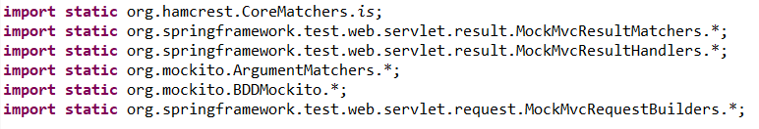

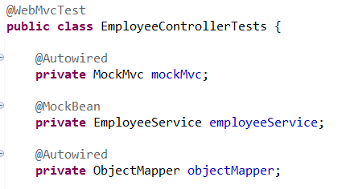



Testing for create new employee

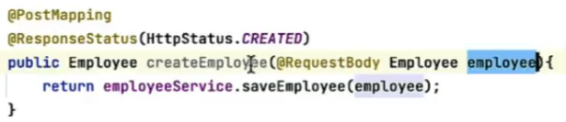



invocation.getArgument(0)- because there’s only one argument in employeeService.saveEmployee(emp);

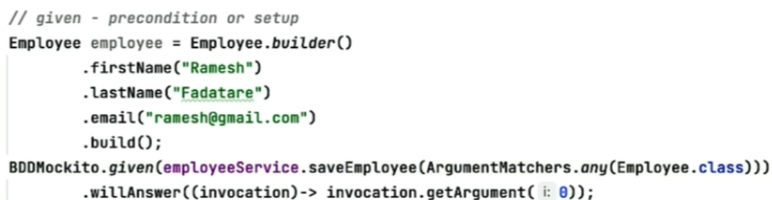

mockMvc.perform(post(“/api/employees”) – performing a post on uri

contentType is json

content is employee json object in body

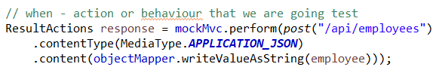

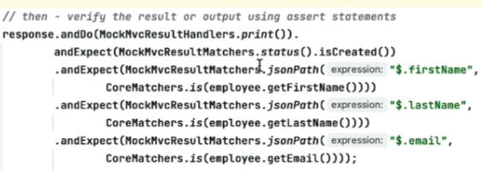

Get all employee

To test

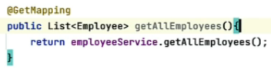

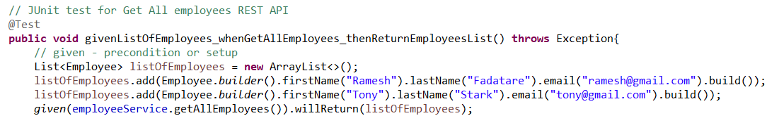



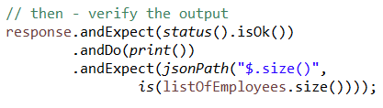

Get employee by id

Positive scenario

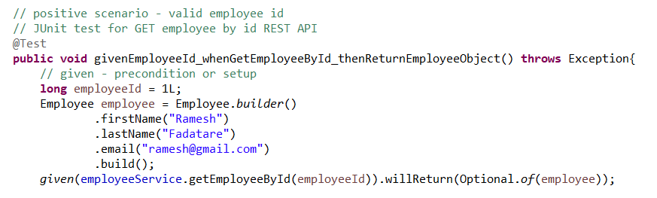



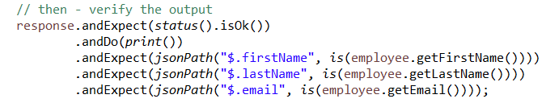

Negative scenario

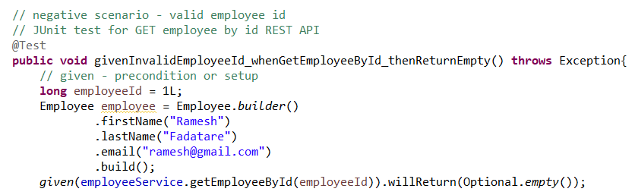





Update employee

Positive scenario

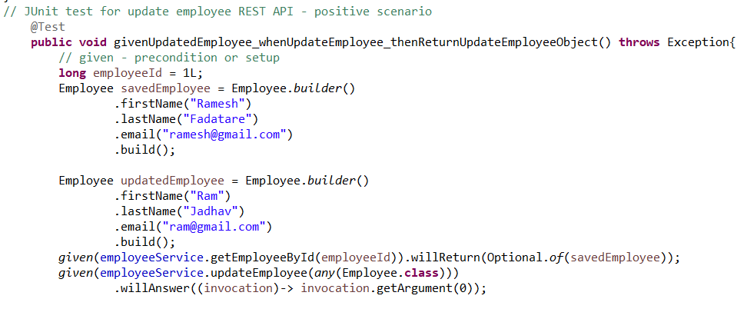

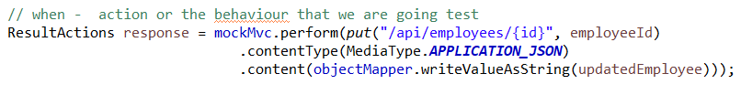

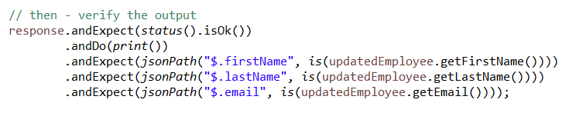

Negative scenario

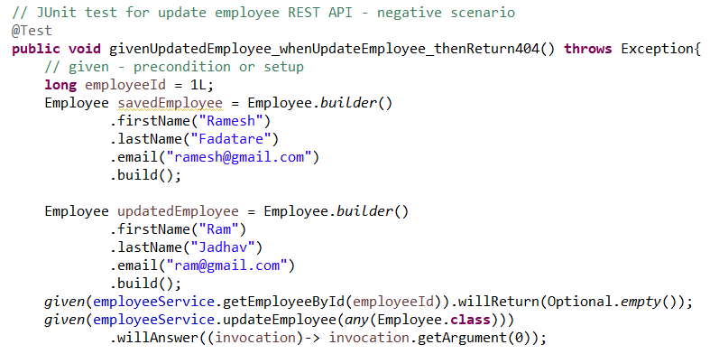

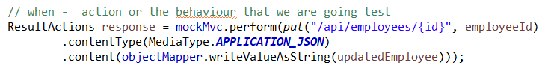

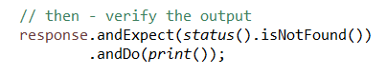

Delete

willDoNothing is used when void is returned

